Ali Dowlatshahi

Jessica Dean

Martian Lapadateschu

CS 4320

Project 2: Architecture and System Design Process (Team)

September 18th, 2019

Table of Contents

1. Cover Page
2. Table of Contents
3. Overview and Questions
4. Use-Case Diagram and Description
5. Activity Diagram 1
6. Activity Diagram 2
7. Activity Diagram 3
8. Class Diagram
9. ERD

(10) Sequence Diagram

(11) State Machine

Overview: This assignment contains UML representation by various methods for a system as described in the individual assignment 2. This is a document containing the Titles, Captions, and Credits to the members of the team who worked on each model. This document will be submitted to Canvas along with a link to my Github repository that contains the individual models and a brief markdown of a description of the assignment that also links to this document.

Questions: There was a bit of a misunderstanding in that the assignment contradicts itself on the ER diagram in which it says at one point it should be system wide while another says it should be for one activity. Additionally, there is some confusion on the deliverable. To make this easy, I am submitting this and a Github link to Canvas that will also reference this document.

Github: <https://github.com/alidowlatshahi/ardrkb>

Use-Case Diagram



This is a Use Case diagram showing the basic process of the Student, TA, and Teacher’s role.

Credits: Construction and Conceptualization by Jessica Dean

Activity Diagram #1

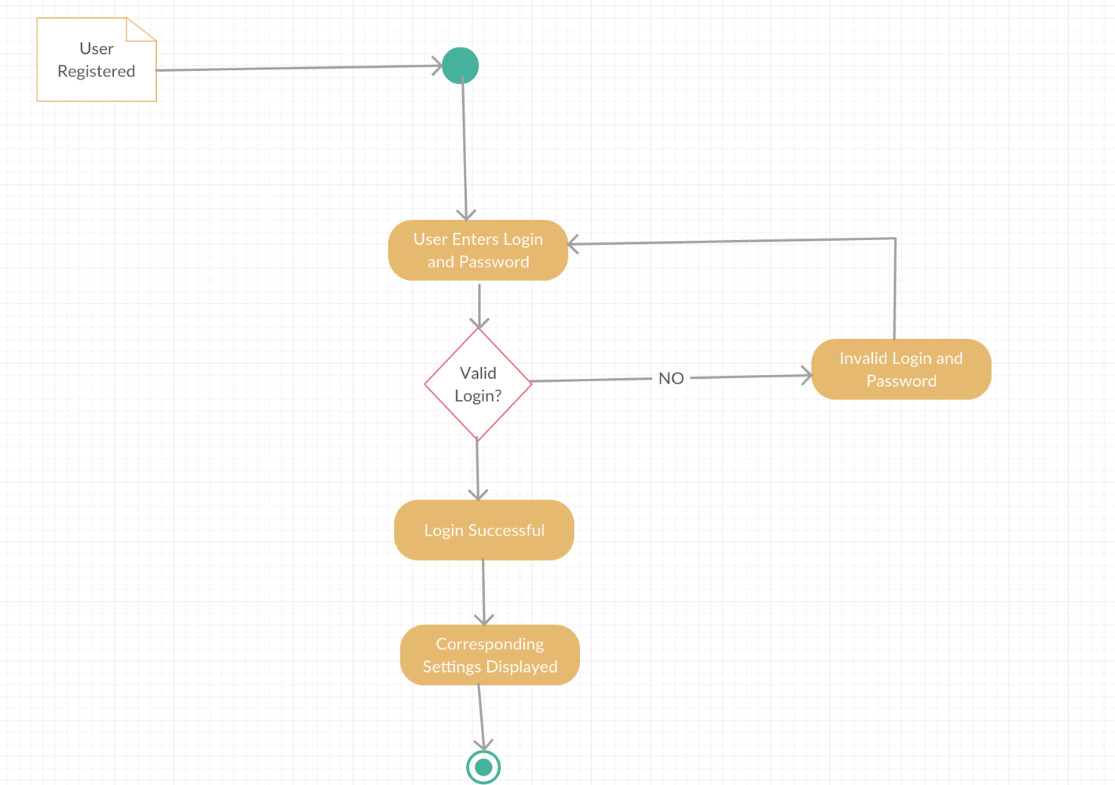

This is our 1st activity diagram. This is demonstrating the login process. This is important because each roles have different permissions.

Credits: Construction and Conceptualization by Ali Dowlatshahi, Conceptualization by Martian Lapadatescu

Activity Diagram #2



This is our 2nd activity diagram showing the grading and downloading process from the TA’s perspective.

Credits: Construction and Conceptualization by Jessica Dean

Activity Diagram #3

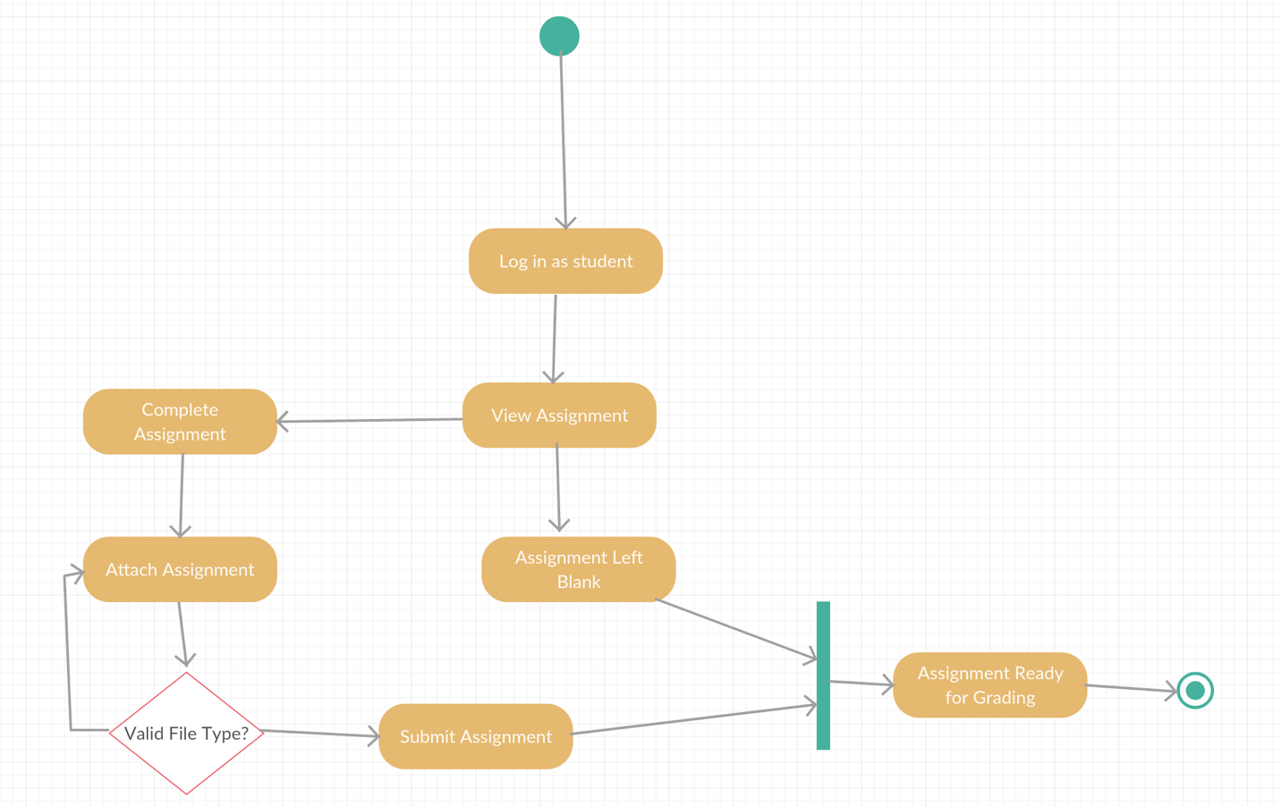

This is our 3rd activity diagram showing the basic submission process with file validation check from the Student’s perspective.

Credits: Construction and Conceptualization by Ali Dowlatshahi, Review by Martian Lapadatescu

Class Diagram

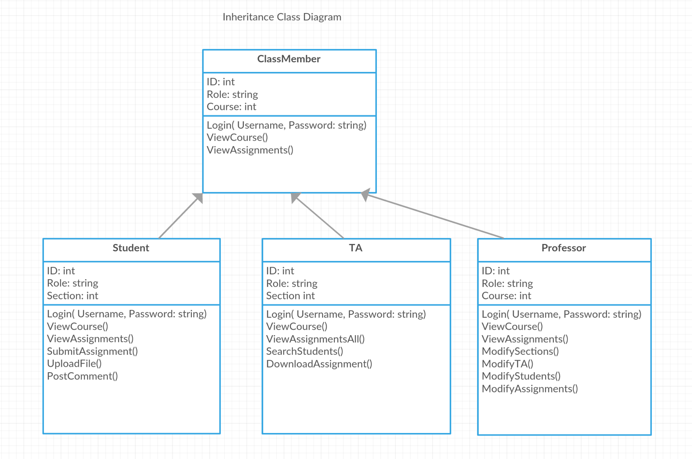

This is a Class Diagram showing the inheritance of being a member in a course and what functions each role has.

Credits: Construction by Ali Dowlatshahi, Conceptualization by Jessica Dean

ERD

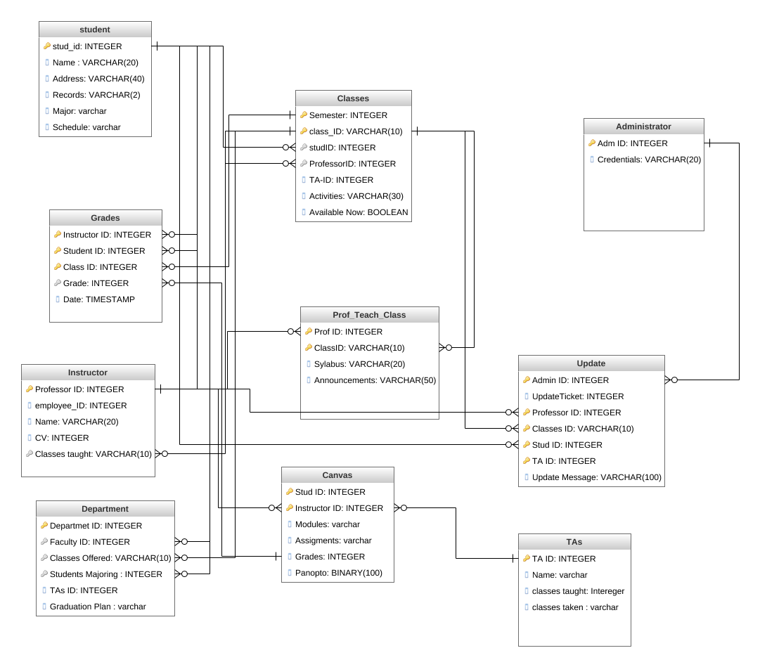

This is an ER diagram. For simplicity, it is in more of a table relational state. This is a system wide diagram.

Credits: Constriction and Conceptualization by Martian Lapadatescu

Sequence Diagram

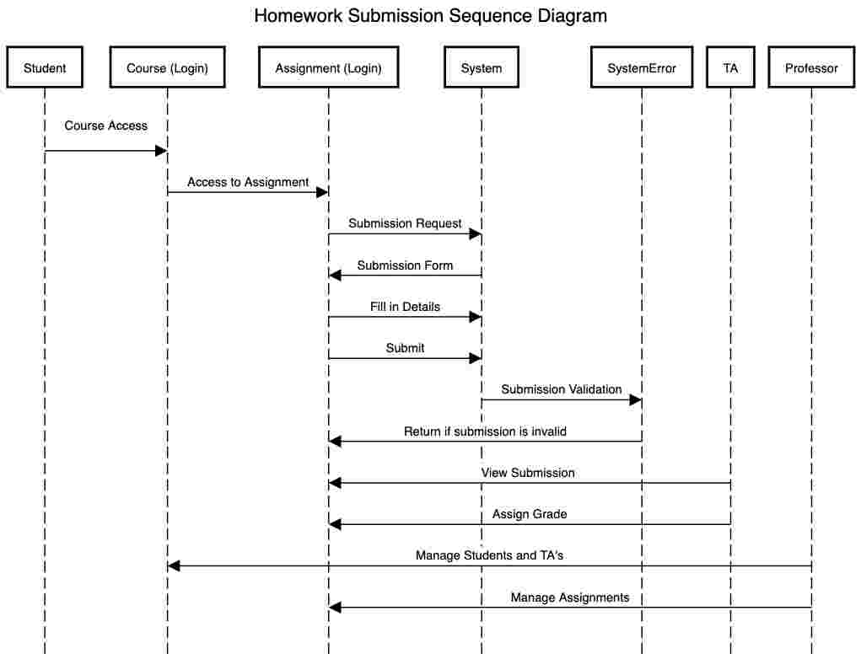

This is our Sequence Diagram showing the process of submission along with error check and the flow of how an assignment develops through each role.

Credits: Construction and Conceptualization by Ali Dowlatshahi

State Machine

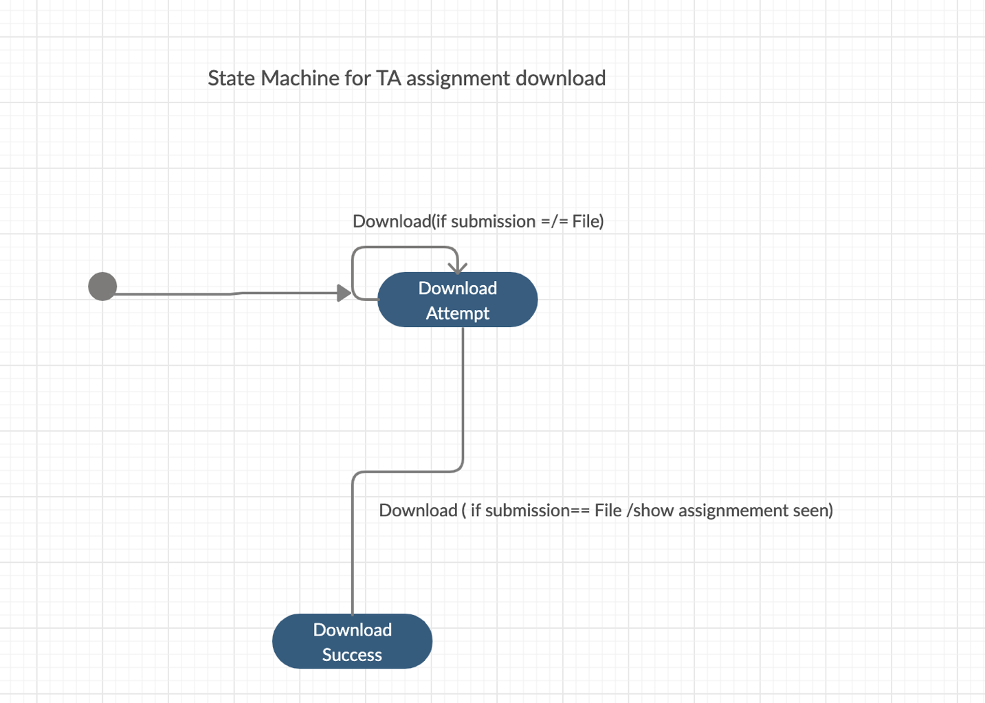

This is our state machine showing the process of a TA downloading a file and it showing as viewed to the student.

Credits: Construction by Ali Dowlatshahi, Conceptualization by Martian Lapadatescu